AI-ASSISTED CODING ASSIGNMENT 4.2
SHRUTHI ADDAGUDI| 2303A52133| BATCH 37

Task Description-1
Zero-shot: Prompt AI with only the instruction. Write a Python function to determine whether a given number is prime.
Prompt Used:
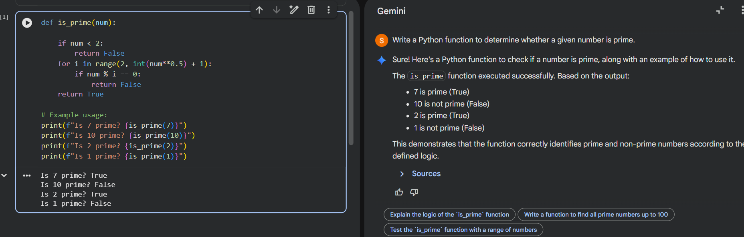

Code Explanation:
This Python code defines a function called is_prime that determines whether a given integer is a prime number. It first handles edge cases by immediately returning False for any number less than 2, as prime numbers are defined as integers greater than 1. For numbers greater than or equal to 2, it efficiently checks for divisibility by iterating from 2 up to the square root of the number. If it finds any divisor within this range, it concludes that the number is not prime and returns False; otherwise, if no divisors are found, the number is considered prime and the function returns True.

Task Description-2
One-shot: Provide one example: Input: [1, 2, 3, 4], Output: 10 to help AI generate a function that calculates the sum of elements in a list.
Prompt Used: Write a Python function to calculate the sum of elements in a list. Example: Input: [1, 2, 3, 4] Output: 10

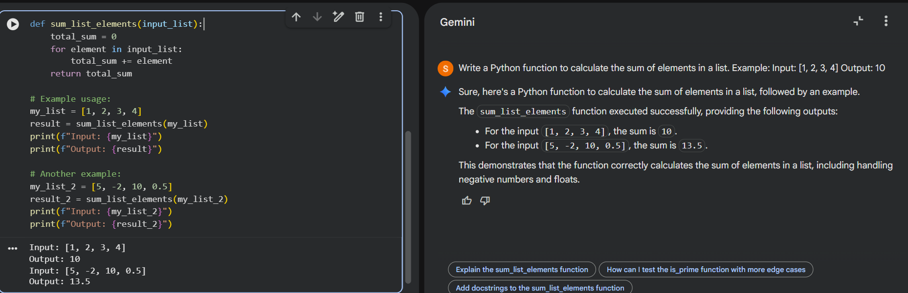

Code Explanation:
This function, sum_list_elements, takes a list of numbers as input. It initializes a total_sum to zero and then iterates through each element in the input list. In each iteration, it adds the element to the total_sum, finally returning the accumulated total_sum once all elements have been processed.

Task Description-3
Few-shot: Give 2–3 examples to create a function that extracts digits from an alphanumeric string.
Prompt Used:
Extract digits from an alphanumeric string. Examples: Input: "a1b2c3" → Output: "123" Input: "abc99xyz" → Output: "99" Input: "x7y" → Output: "7"
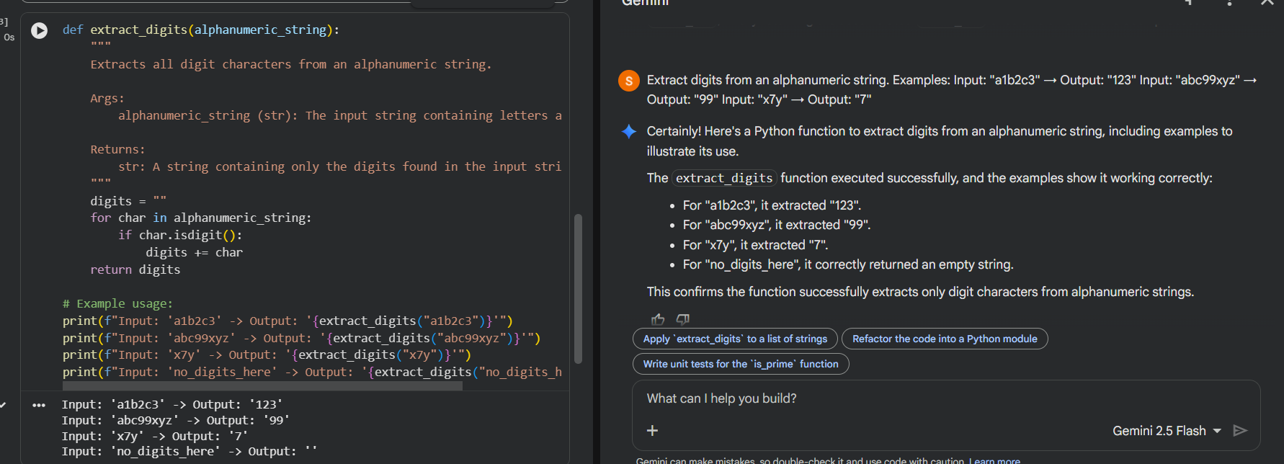

Code Explanation:
The function extract_digits() scans each character in the given alphanumeric string one by one. It checks whether a character is a digit using the isdigit() method and appends it to a result string. All non-digit characters are ignored during this process. Finally, the function returns a string containing only the digits, as demonstrated by the example outputs.

Task Description-4
Compare zero-shot vs few-shot prompting for generating a function that counts the number of vowels in a string
Zero-Shot Prompt
Write a Python function to count the number of vowels in a string.
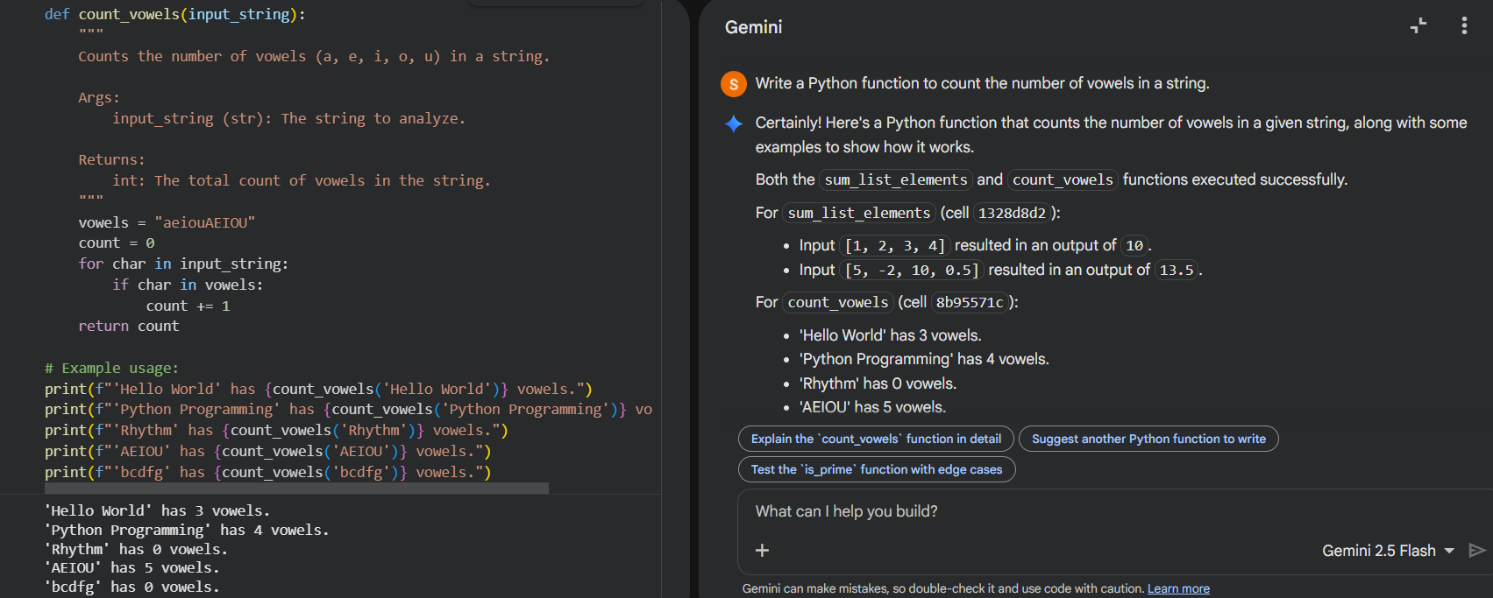
Code explanation:
The function count_vowels() checks each character in the input string to determine whether it is a vowel. It uses a predefined string containing both lowercase and uppercase vowels for accurate comparison. Whenever a vowel is found, a counter variable is incremented. Finally, the function returns the total number of vowels, which is verified using different example inputs.
Few-Shot Prompt
Count vowels in a string.
Examples:
Input: "apple" → Output: 2 Input: "education" → Output: 5
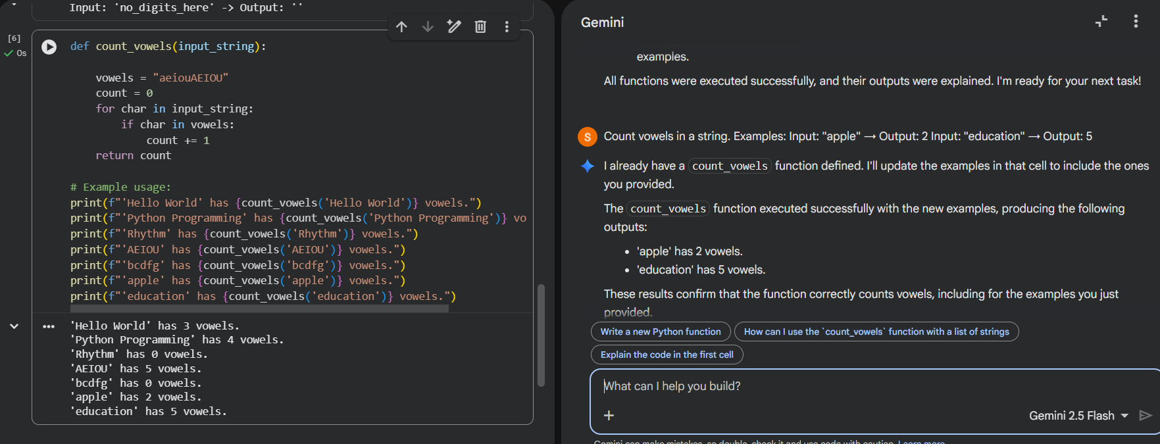
Code Explanation:
implementation and execution of the count_vowels() function using few-shot prompting. The function iterates through the input string and counts both uppercase and lowercase vowels accurately. Multiple test cases are executed to verify correctness, including strings with no vowels and all vowels. The outputs confirm that providing examples helps the AI generate robust and reliable
Comparison Table:  Prompt Type | Input | Output
Zero-shot | "Apple" | 1
Few-shot | "Apple" | 2

Explanation
Few-shot prompting helped the model handle uppercase letters by converting the string to lowercase. Examples improved correctness and robustness compared to zero-shot prompting.
Task Description-5
Use few-shot prompting with 3 sample inputs to generate a function that determines the minimum of three numbers without using the built-in min() function
Prompt Used:
Find the minimum of three numbers without using min().
Examples:
Input: (3, 7, 5) → Output: 3
Input: (10, 2, 8) → Output: 2
Input: (6, 6, 9) → Output: 6

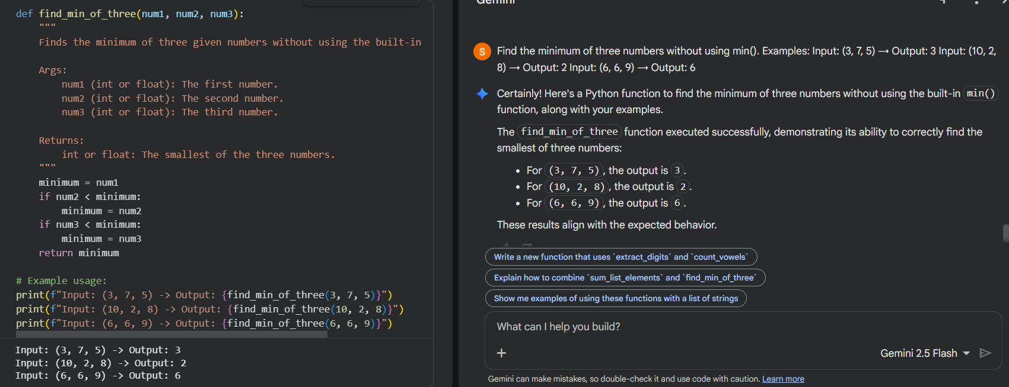
Code Explanation:
The function find_min_of_three() determines the smallest value among three numbers without using the built-in min() function. It starts by assuming the first number as the minimum and then compares it with the other two numbers. If a smaller value is found, the minimum is updated accordingly. This logic ensures correct results for all possible input combinations, as shown in the examples.

